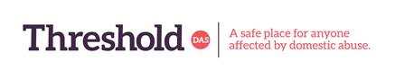
Name |  | Date of request
Full Address

Phone number
Email Address

Number of adults at home

Number of children at home
(Please also state ages)

Currently receiving support from Threshold DAS | Yes/No | Name of Support worker -
Details of any special dietary restrictions due to health/religion

Any known allergies

Subject to availability
Are you interested in receiving-

Dry grocery
Fresh fruit/ veg
Meat
Hygiene products

Threshold DAS is not responsible for the quality or quantity of food given out. We only pass on upon request food that has been received as a donation. Threshold DAS does not guarantee any specific quantity or availability of any specific food item. Individuals accessing the scheme, receiving any food are themselves responsible for checking the suitability for use. If they are in doubt, they must not use the food and discard it. Use of any food item is solely on the individual service users discretion as is checking for allergens they may have.
By completing and signing this form, the individual/ service user is accepting responsibility based on these terms and completely and unconditionally indemnify Threshold DAS in all aspects from any liability

Signature………………………………………….

Office Use

Customer Number….
Date registered……
Support worker ( initials)
Voucher issued by…..
No. of people supported in this parcel…..
No. of food parcels received……

