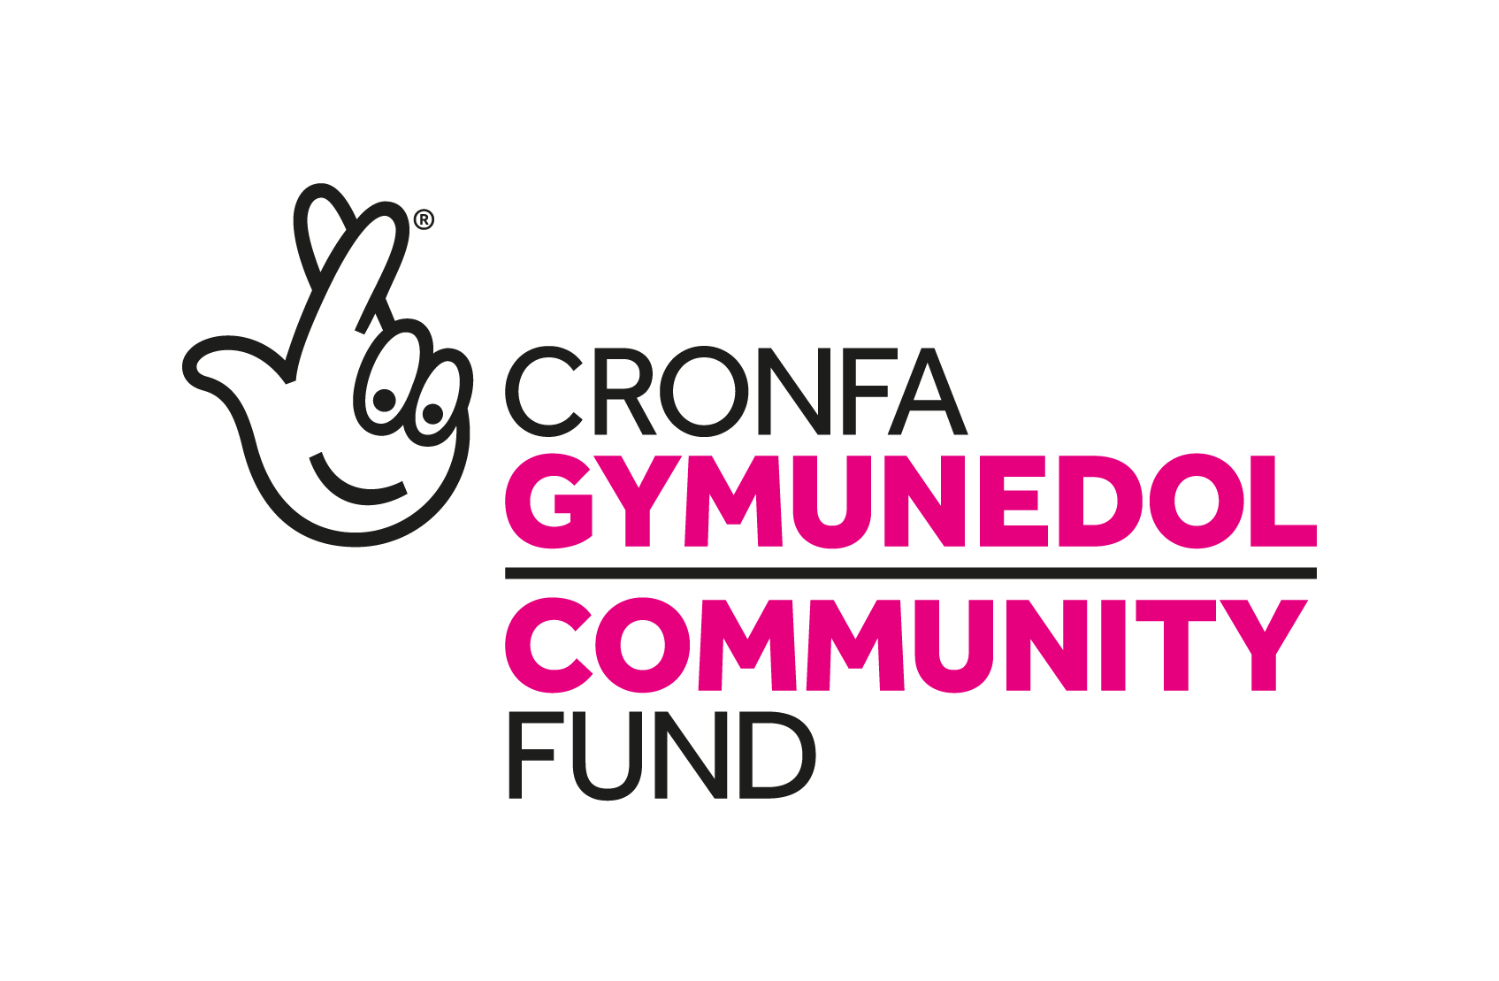

Threshold DAS are recruiting for the exciting new ‘TY RHOSYN’.

Ending Rural Homelessness Project

CARMARTHENSHIRE and CEREDIGION

About the Ty Rhosyn Service

TY RHOSYN Housing Support Services will aim to support vulnerable individuals at risk of homelessness, not just during a crisis, but throughout their journey towards independence.
Prevention and early intervention are key to addressing homelessness in rural areas offering a range of supports to people at risk of eviction, providing crisis and transitional accommodation and helping individuals to find long-term, sustainable, and affordable housing options. Our staff will work with people experiencing domestic abuse, alcohol and drug problems, mental health issues, problem gambling, and other factors that can affect their ability to maintain a tenancy.
There are currently many families and individuals across Wales who are without a home. This includes very visible homelessness, such as people rough sleeping, but also less visible forms, such as people staying in sheds or outhouses, on the sofas of family or friends, or living in hostels and bed and breakfasts without a plan to move on.
The common perception of a homeless person is an older man with a drinking or drug problem who sleeps in an inner-city park or street. However, we know from our experience and Census figures there is no “typical” homeless person.
Homelessness can affect women, men, and children from a wide range of backgrounds living in our cities, towns, and villages.
Yet the problem is often masked by the fact that people experiencing homelessness move from one temporary solution to another, ‘making do’ until they can find permanent accommodation. Some never achieve this.
These individuals, the ‘hidden homeless’, often move between the homes of family members or, as is often the case with individuals who ‘couch surf’, a series of friends.
Some stay in refuges, boarding houses, cheap motels, caravans and even cars. As you can imagine, such uncertainty can take an enormous toll on a person’s self-worth and capacity to go to school, find work and stay healthy.
Homelessness also comes at a high social and economic cost to our society, another reason why prevention is so vital.
TY RHOSYN Housing Support Services is a multi-faceted program of support to identify and address homelessness in rural Carmarthenshire and Ceredigion. Providing a joined-up service that not only addresses current homelessness but also work toward a model that has the visualisation to cease homelessness in the future.

Where we will be working
We will be working in Carmarthenshire and Ceredigion, but we are hoping to extend our Tenancy programme into southeast Wales in years two/three.
There are 4 main partners, all registered charities, and several other partners which are non-financing. The main financed partners are:
- Threshold DAS (Lead)
- Calan Domestic Violence Services (CALAN DVS)
- Carmarthen Domestic Abuse Services (CARM DAS)
- West Wales Domestic Abuse Services (WWDAS)

