Threshold DAS Limited
32 Station Rd.
Llanelli
SA15 1AN
Tel: 01554 752422
enquiries@threshold-das.org.uk

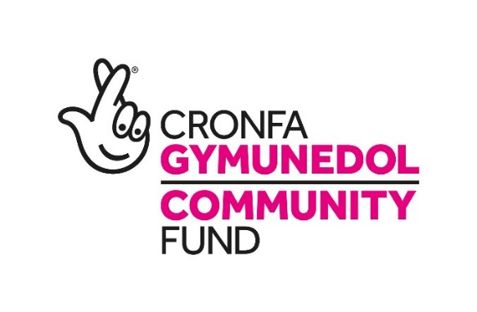

Healthy Relationships Coach – PROJECT Y

Threshold DAS Ltd is an organisation dedicated to the elimination of domestic abuse and sexual violence, Project Sparrow is one of our many projects that strives to achieve this. A bespoke program with the aim of raising awareness in children and young people about the importance of healthy relationships; it covers areas such as social media, sexting and using the internet safely, sexual health and understanding sexual orientation, bullying, peer pressure, substance, drug and alcohol abuse, self-harming and suicide intervention, mental health and healthy eating. This model’s initiative will be delivered in schools, youth clubs, colleges and third party sector organisations that support young people. The project will not only offer a programme of group work, but will also offer advice drop-in services and one-to-one support. Our aim is to provide young people the tools they need to address the issues they feel they need help with, and to nurture their understanding and compassion for a changing social world, in the hope that they mature into a generation that can break the cycle of domestic abuse and sexual violence.

Responsibilities and Duties

1. To work with young people across Carmarthenshire and Pembrokeshire, challenging their perspectives and supporting their development regarding the issues detailed in Project Sparrow’s initiative.

2. To develop engaging methods of delivering the project, tailoring seminars to varying age groups considering appropriateness and teaching techniques.

3. To co-ordinate with the relevant educational advocates, support workers and councillors within the organisation, and third party sectors, to collaborate ideas and increase effectiveness of our dedicated effort as a whole.

4. To provide young people with one-to-one mentorship and support.

5. Build key relationships with partner agencies, local authorities and commissioners throughout Carmarthenshire and Pembrokeshire.

6. Publicise the project by delivering presentations at MARAC, safeguarding meetings, Youth Service, Family First, Dyfed Powys and South Wales Police, Social Work Team meetings and Community Safety Partnership events across South Wales.

7. Dealing with at risk and vulnerable groups, managing development and confidentiality.

8. To keep the Project Manager fully informed at all times regarding the programme’s progress and any issues that may arise.

9. Work toward the continued funding of the project by providing monthly reports and statistics to the Project Manager.

10. Work towards safeguarding children and young people by reporting any concerns to the designated child protection person where appropriate.

Qualifications and Skills

Essential Requirements

Educated to degree level in an appropriate subject, 2:1 or above.
Minimum experience of 1 year working with children or vulnerable groups.
Excellent understanding of child protection.
Basic IT skills.
Presentation skills.
Be presentable and communicate exceptionally.
The ability to engage, be forward thinking, anticipate requirements through own initiative and judgement.
Awareness of the issues detailed in the Sparrow Project.
A clean, full driving license and the ability to travel between locations.
A flexible and adaptable approach.
High level of self-awareness and a non-judgmental and non-directive attitude.
Willingness to take part in training both initial and ongoing.
This post is subject to an enhanced DBS check.

Desirable Requirements

Experience in managing conflict and conflict resolution.
Experience of producing quality written reports to deadlines.
Good knowledge of issues surrounding domestic abuse.
A team player with the ability to work to their own initiative.
Experience of liaising with other agencies both statutory and voluntary.
A willingness to perform any other duties within the general scope of this job profile, as reasonably requested by the Managing Director.
Ability to speak Welsh, conversationally or fluently.

Benefits

An enhanced DBS check is required for most posts. The posts are open to both male and female applicants. Healthcare plan is included and subject to successful completion of probationary period. These posts are funded by the Big Lottery until April 2021. Continuation is subject to funding.

Job Types: Full-time, Contract

Salary: £19,317.00 /year

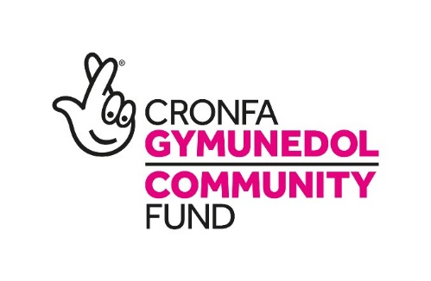

Hyfforddwr Perthynas Iach - PROJECT Y

Mae Threshold DAS Ltd yn sefydliad sy'n ymroddedig i ddileu cam-drin domestig a thrais rhywiol, ac mae Project Sparrow yw un o'n llu o brosiectau sy'n ymdrechu i gyflawni hyn. Mae’n rhaglen bwrpasol sy'n ceisio codi ymwybyddiaeth plant a phobl ifanc am bwysigrwydd perthynas iach ag eraill; mae'n cynnwys meysydd fel cyfryngau cymdeithasol, secstio a defnyddio'r rhyngrwyd yn ddiogel, iechyd rhywiol a deall cyfeiriadedd rhywiol, bwlio, pwysau gan gyfoedion, camddefnyddio sylweddau, cyffuriau ac alcohol, hunan-niweidio ac ymyriadau hunanladdiad, iechyd meddwl a bwyta'n iach. Bydd menter y model hwn yn cael ei chyflwyno mewn ysgolion, clybiau ieuenctid, colegau a sefydliadau sector trydydd parti sy'n cefnogi pobl ifanc. Bydd y prosiect nid yn unig yn cynnig rhaglen o waith grŵp, ond bydd hefyd yn cynnig cyngor galw heibio a chymorth un i un. Ein nod yw rhoi’r offer sydd eu hangen ar bobl ifanc i fynd i'r afael â'r materion maent yn teimlo y mae angen help arnynt, a meithrin eu dealltwriaeth a'u tosturi am fyd cymdeithasol sy'n newid, yn y gobaith y byddant yn aeddfedu i fod yn genhedlaeth a all dorri cylch cam-drin domestig a thrais rhywiol.

Cyfrifoldebau a dyletswyddau

1. Gweithio gyda phobl ifanc ar draws Sir Gaerfyrddin a Sir Benfro, gan herio eu safbwyntiau a chefnogi eu datblygiad o ran y materion a nodwyd ym menter Project Sparrow.

2. Datblygu dulliau diddorol o gyflwyno'r prosiect, teilwra seminarau i wahanol grwpiau oedran gan ystyried priodoldeb a thechnegau addysgu.

3. Cydlynu gydag eiriolwyr addysgol perthnasol, gweithwyr cefnogi a chynghorwyr o fewn y sefydliad, a sectorau trydydd parti, i gydweithredu ar syniadau a chynyddu effeithiolrwydd ein hymdrech benodol yn gyffredinol.

4. Darparu mentora a chymorth un-i-un i bobl ifanc.

5. Meithrin perthynas allweddol gydag asiantaethau partner, awdurdodau lleol a chomisiynwyr ledled Sir Gaerfyrddin a Sir Benfro.

6. Rhoi cyhoeddusrwydd i'r prosiect drwy gyflwyno cyflwyniadau yn MARAC, mewn cyfarfodydd diogelu, y Gwasanaeth Ieuenctid, Teuluoedd yn Gyntaf, Heddlu Dyfed Powys a Heddlu De Cymru, cyfarfodydd Tîm Gwaith Cymdeithasol a digwyddiadau Partneriaeth Diogelwch Cymunedol ledled de Cymru.

7. Delio â grwpiau sydd mewn perygl a grwpiau agored i niwed, gan reoli datblygiad a
chyfrinachedd.

8. Rhoi gwybod i'r Rheolwr Prosiect yn gyson am gynnydd y rhaglen ac unrhyw fater a allai godi.

9. Gweithio tuag at gyllido'r prosiect yn barhaus drwy ddarparu adroddiadau ac ystadegau misol i Reolwr y Prosiect.

10. Gweithio tuag at ddiogelu plant a phobl ifanc drwy adrodd am unrhyw bryder i'r unigolyn amddiffyn plant dynodedig lle bo'n briodol.

Cymwysterau a Sgiliau

Gofynion Hanfodol

Addysg at lefel gradd mewn pwnc priodol, 2:1 neu uwch.
Isafswm o flwyddyn o brofiad yn gweithio gyda phlant neu grwpiau agored i niwed.
Dealltwriaeth ardderchog o amddiffyn plant.
Sgiliau TG sylfaenol.
Sgiliau cyflwyno.
Bod yn barod a chyfathrebu'n rhagorol.
Y gallu i ymgysylltu, bod yn flaengar, a rhagweld gofynion drwy eu menter a'u barn eu hunain.
Ymwybyddiaeth o'r materion y manylwyd arnynt ym Mhrosiect Sparrow.
Trwydded yrru lân, lawn a'r gallu i deithio rhwng lleoliadau.
Agwedd hyblyg a pharodrwydd i addasu.
Lefel uchel o hunanymwybyddiaeth ac agwedd anfeirniadol, anghyfeiriol.
Parodrwydd i gymryd rhan mewn hyfforddiant cychwynnol a pharhaus.
Bydd gofyn cael archwiliad manwl gan y Gwasanaeth Datgelu a Gwahardd ar gyfer y swydd hon.

Gofynion Dymunol

Profiad o reoli gwrthdaro a datrys gwrthdaro.
Profiad o gynhyrchu adroddiadau ysgrifenedig o safon o fewn terfynau amser.
Gwybodaeth dda am faterion yn ymwneud â cham-drin domestig.
Chwaraewr tîm gyda'r gallu i weithio ar eich liwt eich hun.
Profiad o gysylltu ag asiantaethau eraill, yn rhai statudol a gwirfoddol.
Parodrwydd i gyflawni unrhyw ddyletswydd arall o fewn cwmpas cyffredinol y proffil swydd hwn, yn unol â cheisiadau rhesymol gan y Rheolwr Gyfarwyddwr.
Y gallu i siarad Cymraeg, yn llafar neu'n rhugl.

Buddion

Mae gofyn cael archwiliad manwl gan y Gwasanaeth Datgelu a Gwahardd ar gyfer y rhan fwyaf o swyddi. Mae'r swyddi yn agored i ymgeiswyr gwryw a benyw. Mae cynllun gofal iechyd yn gynwysedig ac yn amodol ar gwblhau cyfnod prawf yn llwyddiannus. Cyllidir y swyddi hyn gan y Loteri Fawr tan Ebrill 2021. Mae parhad yn amodol ar gyllid.
Mathau o swydd: Amser llawn, contract

Cyflog: £19,317.00 y flwyddyn

